### CHANDIGARH COLLEGE OF ENGINEERING AND TECHNOLOGY

**(DEGREE WING)**

Government Institute under Chandigarh (UT) Administration, Affiliated to Panjab University, Chandigarh

Sector-26, Chandigarh. PIN-160019

#### 2024

## Bachelor of Engineering

**IN COMPUTER SCIENCE AND ENGINEERING**

**3rd Sem**



**DBS PRACTICAL - 2**

**Submitted by Submitted To**

## Sanatan Sharma Dr. Dheerendra Singh

**(Roll no:CO23355) (Professor)**

Practical – 2

Aim:

To import and export banking and university database using XAMPP server.

PROCEDURE:

To import database to XAMPP server.

1. Banking Database

Step-1: Go to XAMPP server Apache (Admin)

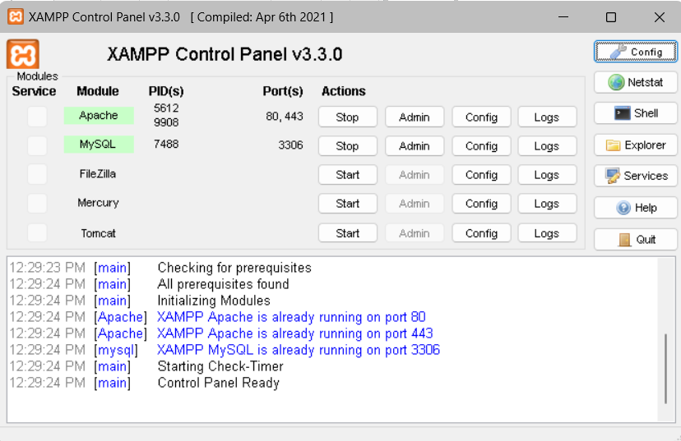

2: Open “phpMyAdmin”



3: Click on “new” on left-hand side

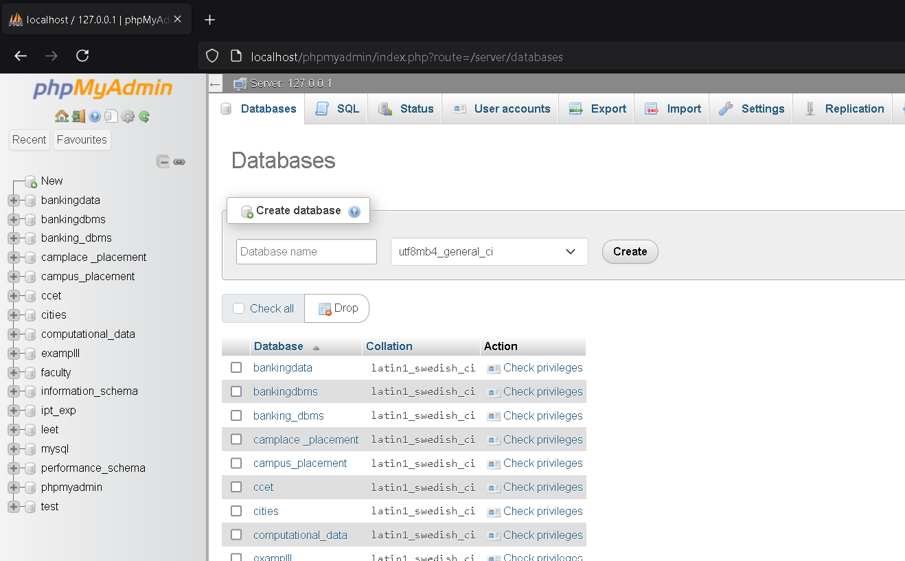

4: Enter the database name “banking” and click on “create”.

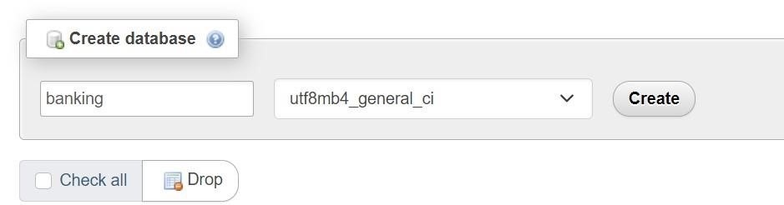

5: Click on database just created. Then click on “import” in the top bar.

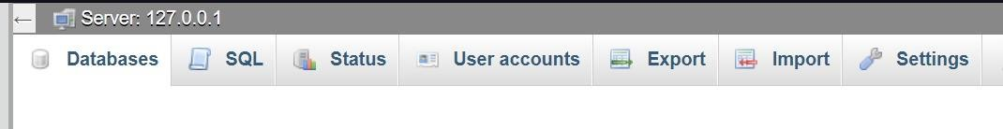

6: Click on choose file.

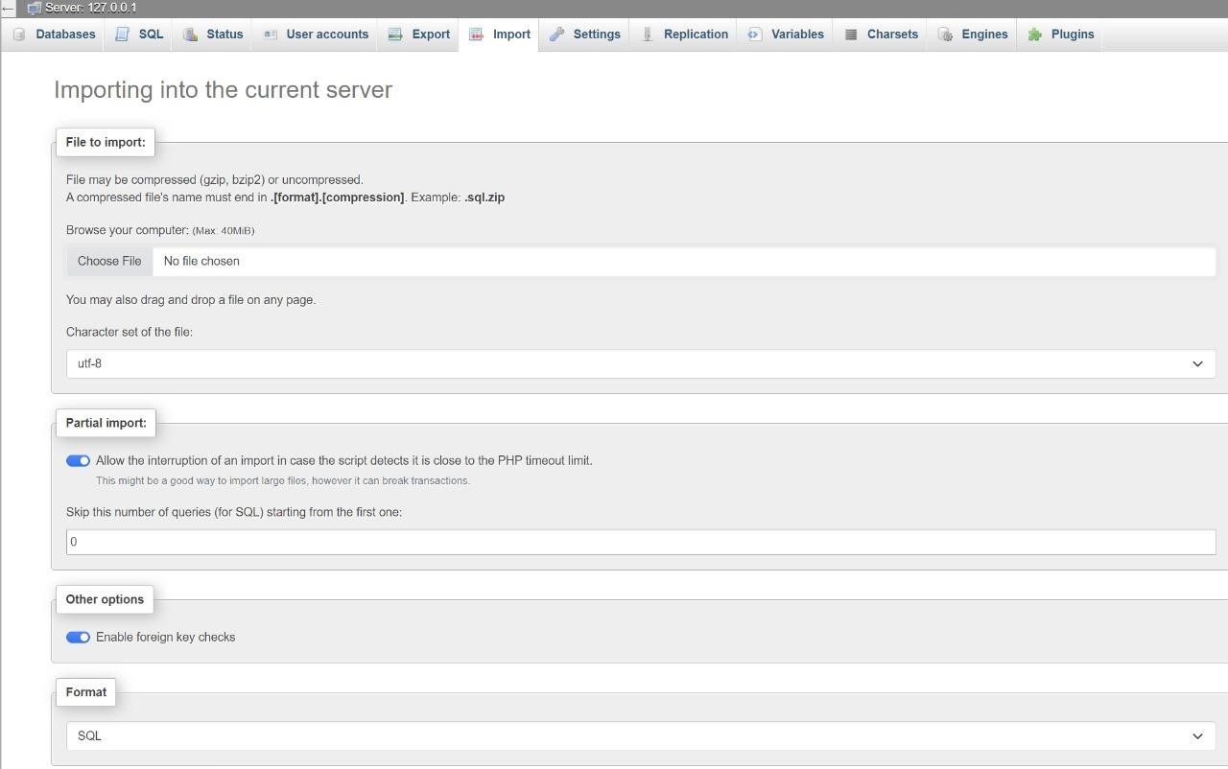

7: Choose the file naming “bankingdbms_c” from your computer and click “open”.

**NOTE: File extension should be “.sql”**

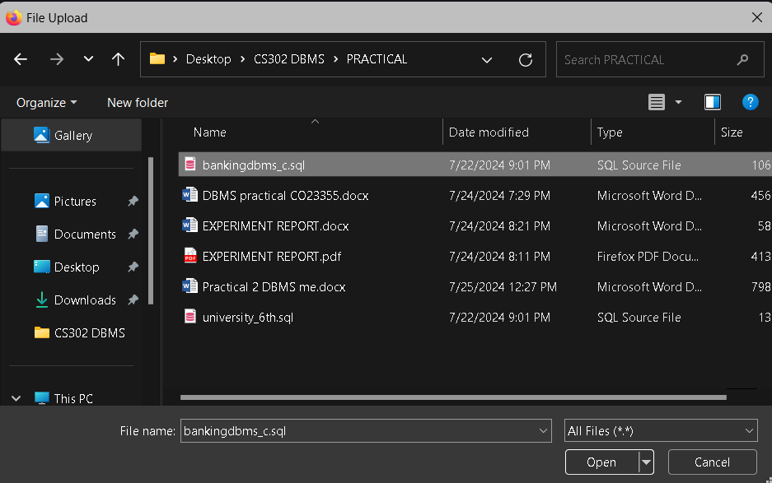

Step-8: After the file has been selected, click on “import”

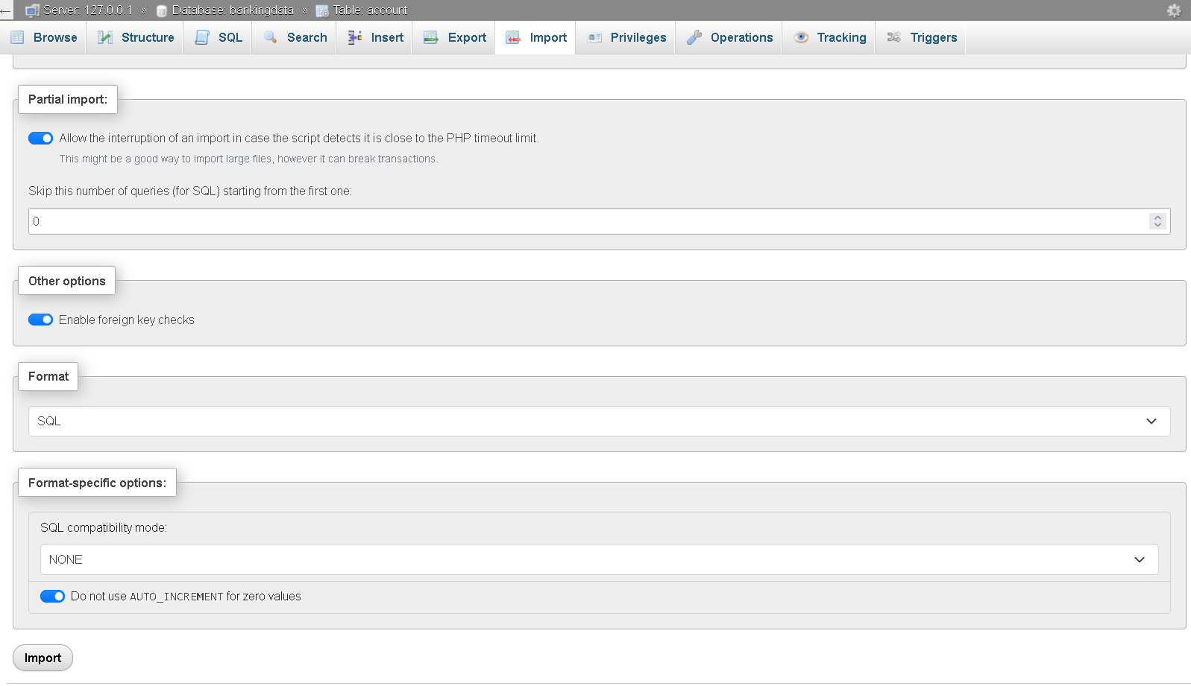

Step-9: A message is displayed that the “import has been successfully finished”.

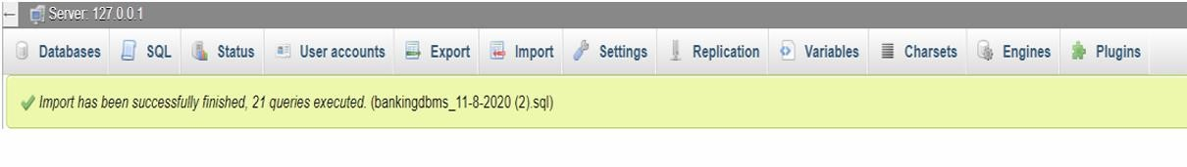

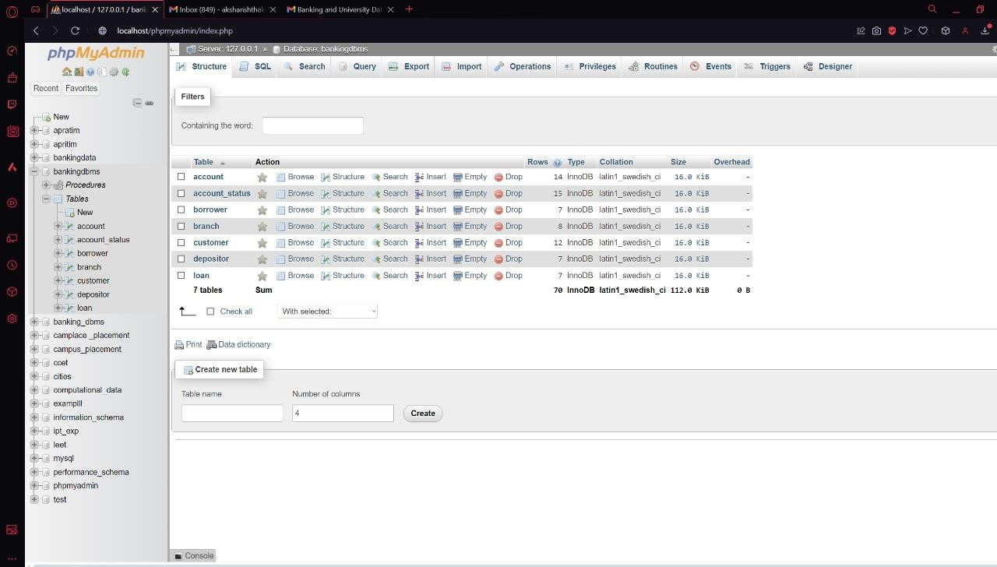

**NOW,**

To export database from XAMPP server.

1: Navigate to “phpMyAdmin” and select database which you want to export.

2: Click on “export” tab

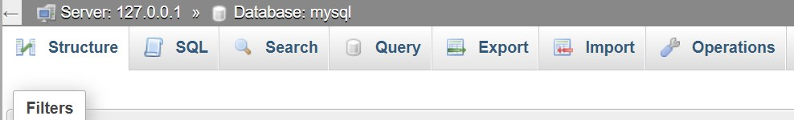

3: Select “export method” and “format”. Click Export.

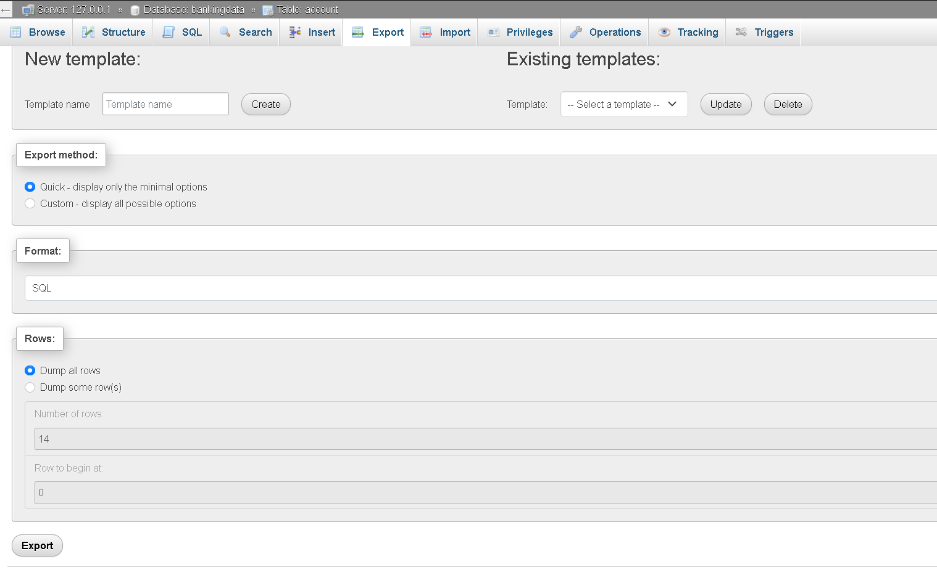

4: Database has been successfully exported.

